**HDSC August’22 Premiere Project**

**TEAM TABLEAU**

CYBERSECURITY RISK ANALYSIS

**Project Description**

Something no one wants is to be exposed or feel insecure about personal information while surfing the web. The task is to analyze the severity of different security vulnerabilities over time in order to measure effectiveness of cybersecurity efforts, build a data visualization tool to showcase the different types, CVSS scores, vendor projects and products names associated with security vulnerabilities over time

**About the Dataset**

The dataset presents an in-depth exploration of the security vulnerabilities across the United States from the CISA Known Exploited Vulnerabilities catalog for 2022. You'll find a number of vulnerability types and severity levels, as well as CVSS scores, vendor projects, product names, and other pertinent information.

**Aim and Objective**

The goal of this project is

1. Analyze the severity of different security vulnerabilities over time in order to measure effectiveness of cybersecurity efforts.
2. To build data visualization graphs to showcase the different types, CVSS scores, vendor projects and products names associated with security vulnerabilities over time in the US.
3. Perform statistical analysis to identify the relationship between vulnerabilities associated variables

**Tools:** During the course of analysis, we made use of Jupiter Notebook, Microsoft Excel and Microsoft Power BI

**FLOW PROCESS**









**Data Gathering**

The dataset for this project was obtained from Kaggle via the link below

<https://www.kaggle.com/datasets/thedevastator/exploring-cybersecurity-risk-via-2022-cisa-vulne>

**Data Preparation:**

* Data Compilation: we were provided with five datasets for different dates which were compiled together into one single dataset
* Data Discovery: we noticed early on that the five datasets contain the same entries with few differences causing the compiled dataset to have duplicate ‘cve_id’s.
* Data Cleaning: This involves grouping the compiled dataset by the ‘cve_id’ and filling in missing values with the corresponding value found in the same column and later dropping rows with duplicated ‘cve_id’. The remaining missing values were dropped as well as data that do not contribute to the overall performance of the analysis
* Data Transformation: The date columns were converted into datetime objects and from them new columns were created for days, years and months

**Data Analysis**

During our exploration, we were able to answer questions such as

What are the top 5 products with the most vulnerabilities

|  |  |
| --- | --- |
| **Product** | **No of Vulnerabilities** |
| Windows | 63 |
| Chromium V8 Engine | 17 |
| Win32k | 15 |
| Chrome | 14 |
| iOS | 13 |

*Table 1: Top 5 Products with the most vulnerabilities*

What are the top 5 vendors with the most vulnerabilities

|  |  |
| --- | --- |
| **Vendor** | **No of Vulnerabilities** |
| Microsoft | 171 |
| cisco | 56 |
| apple | 39 |
| google | 35 |
| apache | 20 |

*Table 2: Top 5 vendors with the most vulnerabilities*

How many vulnerabilities were added in the year 2022 and 2021

|  |  |
| --- | --- |
| **Year** | ***No of Vulnerabilities*** |
| 2022 | 2429 |
| 2021 | 1555 |

*Table 3: No of vulnerabilities added in each year*

What day was the highest number of vulnerability added

**‘2021-11-03’ - 276**

And so on

**Data Visualization**

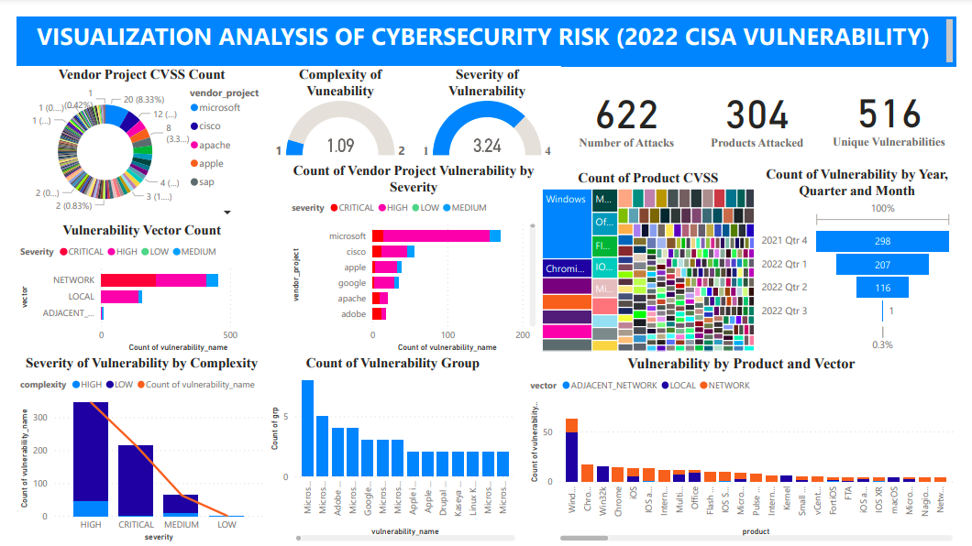

*Figure 1: PowerBI dashboard*

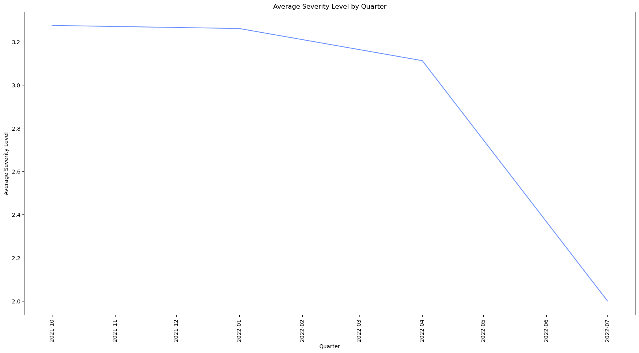

*Figure 2: Average severity level by Quater*

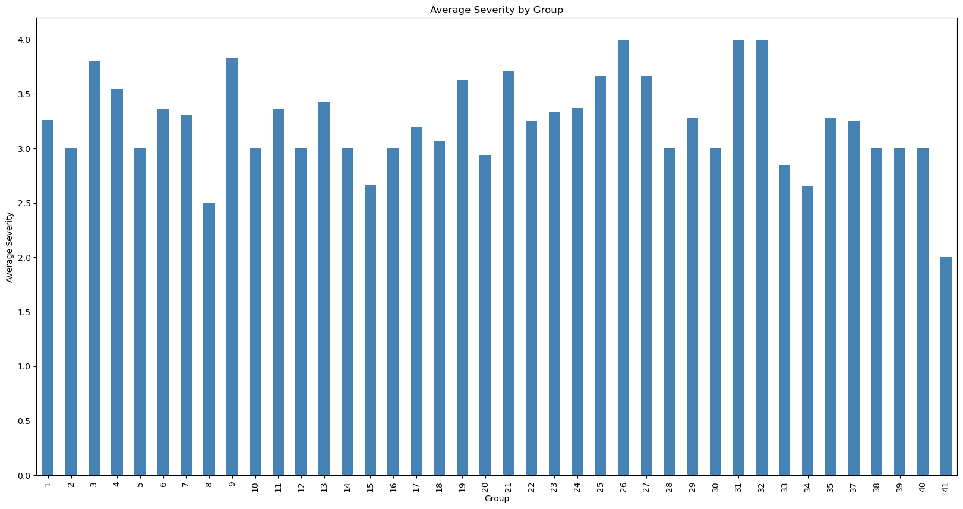

*Figure 3: Average severity level by group*

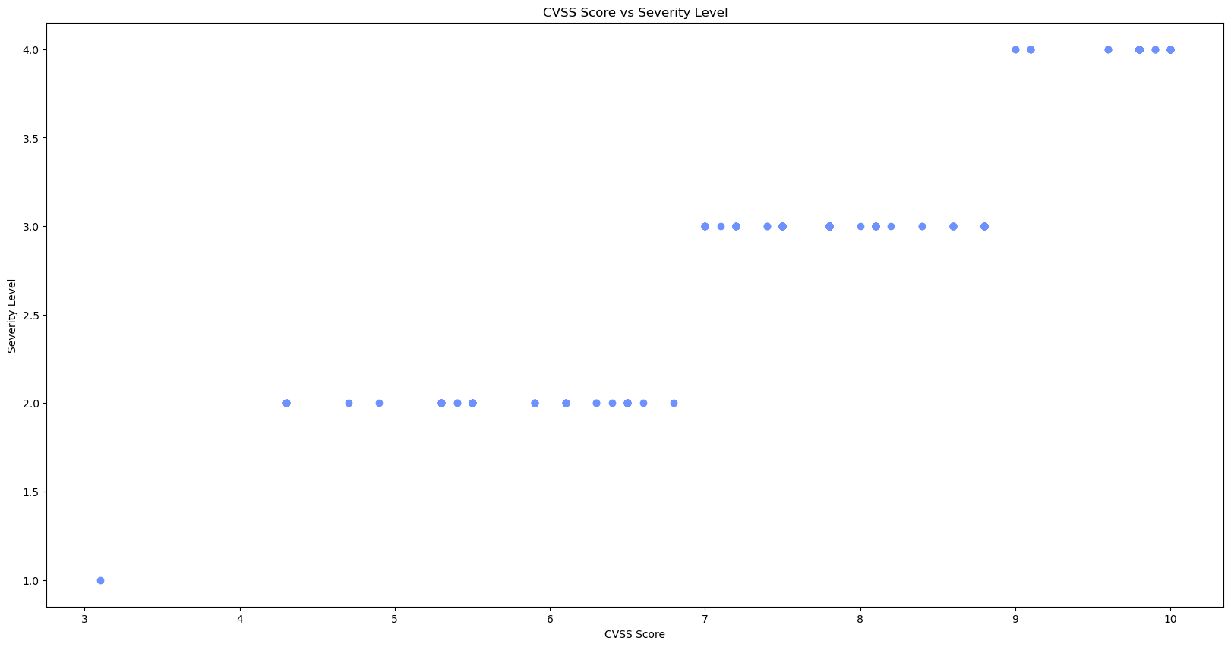

*Figure 4: Severity level VS CVSS score*

**Hypothesis Testing**

We performed some statistical analysis to test the relationship between the associated variables of the vulnerabilities

### **H1: Vulnerabilities with higher CVSS scores are more likely to have a higher severity level.**

Correlation coefficient between CVSS score and severity level is 0.9270402556785979

This indicates a strong positive correlation between CVSS score and severity level. This means that as CVSS score increases, severity level increases. In other words, more severe vulnerabilities tend to have higher CVSS scores.

### **H2: Vulnerabilities discovered earlier (date_added) are more likely to have a higher severity level.**

Performing one-way ANOVA to test for differences between groups gives the result

One-way ANOVA Results:

F-Statistic: 3.328409606331009

p-value: 0.01931663489681124

This means that there is a statistically significant difference between the average severity levels of the four quarters. In other words, the data suggests that the average severity level of vulnerabilities increased from 2021Q4 to 2022Q3.

### **H3: Vulnerabilities in certain CWE categories are more likely to have a higher severity level.**

By performing a chi-square test for association between CWE category and severity level

Chi-Square Test Results:

Chi-Square: 441.3452724662253

p-value: 3.329756781851147e-16

The analysis suggests that the CWE category is related to the severity levels of vulnerabilities. The average severity levels vary across different CWE categories, and the chi-square test indicates a significant association between CWE category and severity

### **H4: Vulnerabilities with a shorter time frame between discovery (date_added) and the due date are more likely to have a higher severity level.**

By performing ANOVA to evaluate the differences in severity levels across time frames

ANOVA Results:

F-Statistic: 2.557321207214212

p-value: 0.07833084700446755

Based on the analysis we conducted to test the hypothesis that vulnerabilities with a shorter time frame between published and the due date are more likely to have a higher severity level, the results suggest that there is no strong evidence to support this hypothesis.